Understand the basic linux commands with Java Installation

Generally, there are 2 users for one Linux server. 1.root/ admin and ec2-user(custom)

Install MobeXterm server to connect to Linux server.

You need to install java, maven etc to this instance.

For that you don’t have access to install using ec2-user, So use root user(default one to install softwares)

**Sudo su - --->** To go to the root user([root@ip-172-31-43-22 ~]#)

[OpenJDK: Download and install](https://openjdk.org/install/)

Choose fedora as linux is for aws, install java

Inorder to visible to all the softwares in the system, we need to set environmental variable path of java. To do so , we need to go to **.bash_profile**

To open the content of the file , use **cat filename**

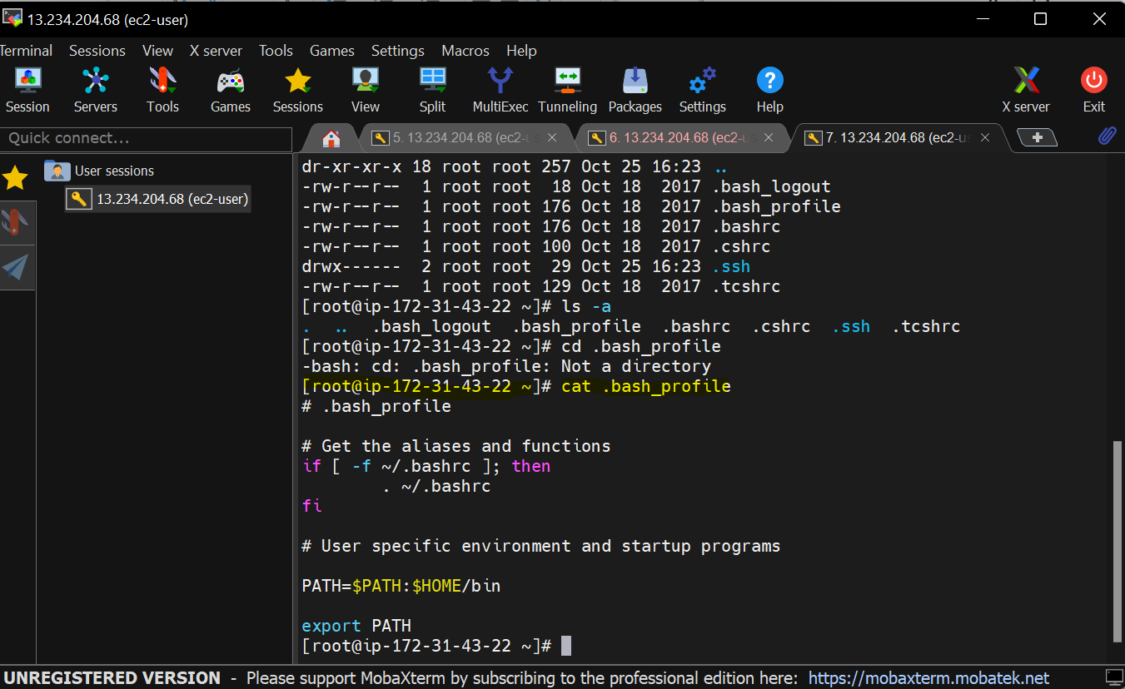

Setting Java and Maven path in Bash Profile in Linux

In this content provide java path

Generally java and other liberaries will be stored under **usr/lib** directory

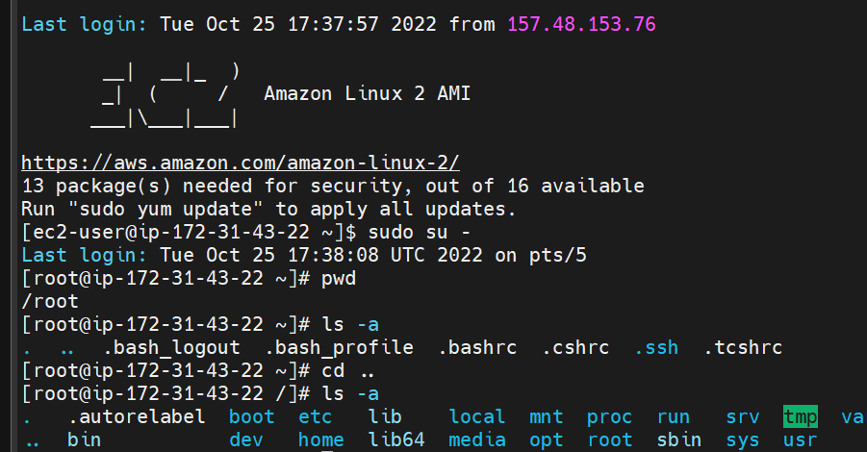

Go to /🡪usr🡪lib🡪jvm🡪select the java path

To find java path find /usr/lib/jvm/java-1.8* | head -n 3

/usr/lib/jvm/java-1.8.0-openjdk-1.8.0.342.b07-1.amzn2.0.1.x86_64

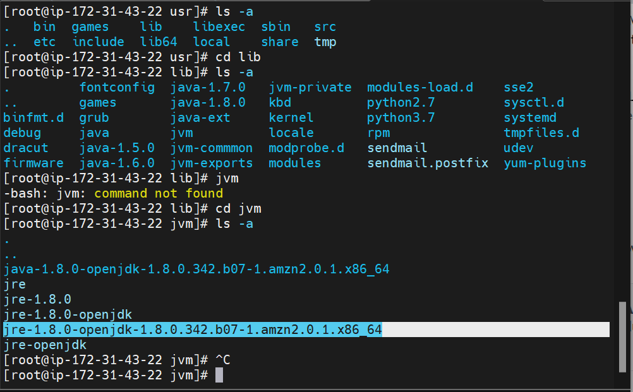

Setting java path

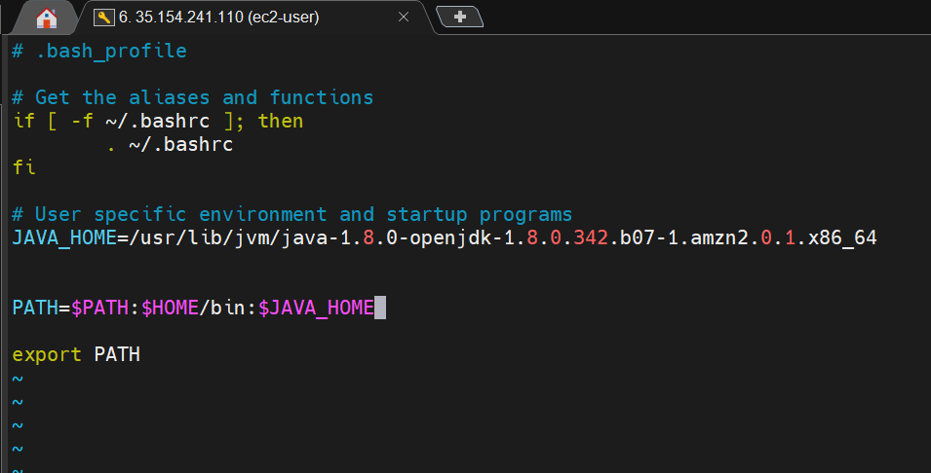

Store path of the java in one variable JAVA_HOME

And add it to the path

To check if it is added as environmental var, use **cat** and to know the path, use which java

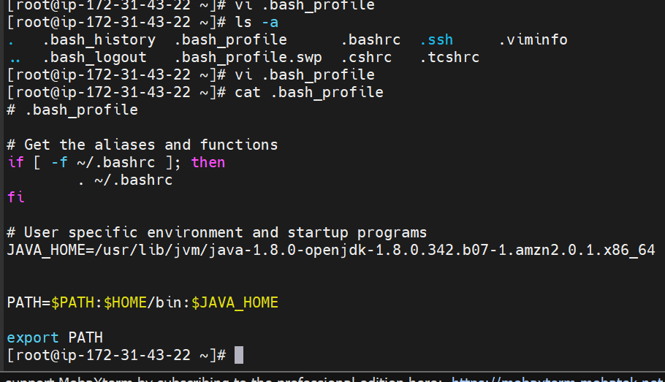

Installing Maven in Linux(root account)

Use **wget** because you wont find maven in yum package.

wget <https://dlcdn.apache.org/maven/maven-3/3.8.6/binaries/apache-maven-3.8.6-bin.tar.gz>

Unzip it in linux using **tar xzvf apache-maven-3.8.6-bin.tar.gz**

Now copy the maven to opt folder using **cp apache-maven-3.8.6 /opt**

Give all the files in a directory to the req path by **cp -r apache-maven-3.8.6 /opt**

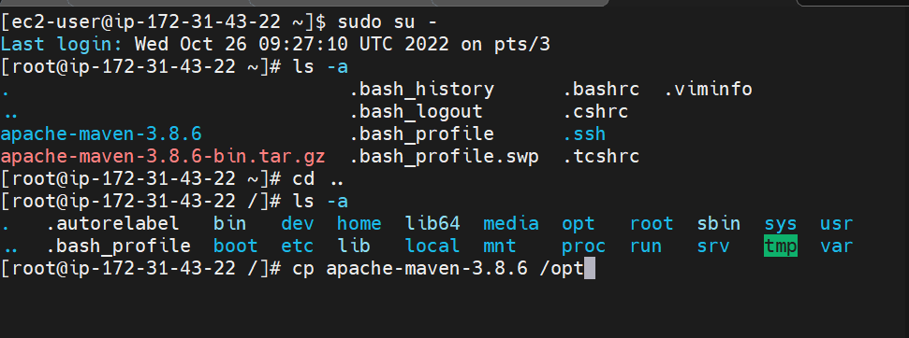

Now maven is copied to /opt folder

[root@ip-172-31-37-77 ~]# cp apache-maven-3.8.6 /opt

cp: omitting directory ‘apache-maven-3.8.6’

[root@ip-172-31-37-77 ~]#

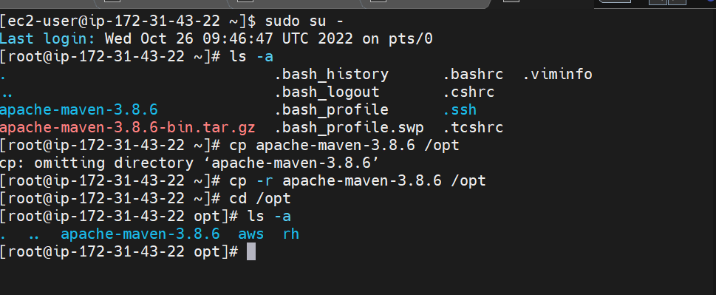

Now give 2 paths of maven into root directory.

Bin path and maven

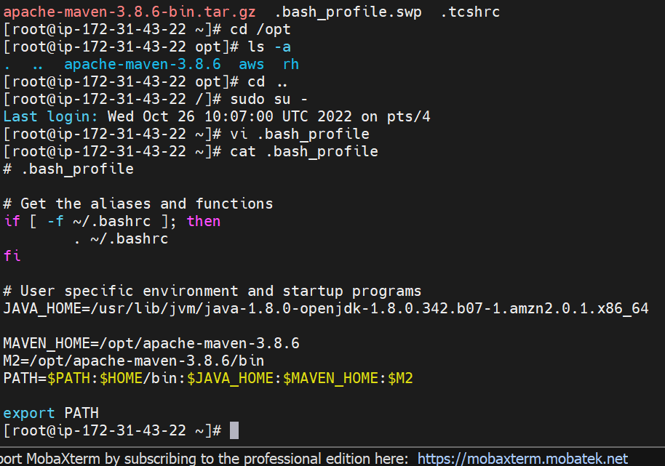

Install Jenkins:

Java is required to install Jenkins, but we already have

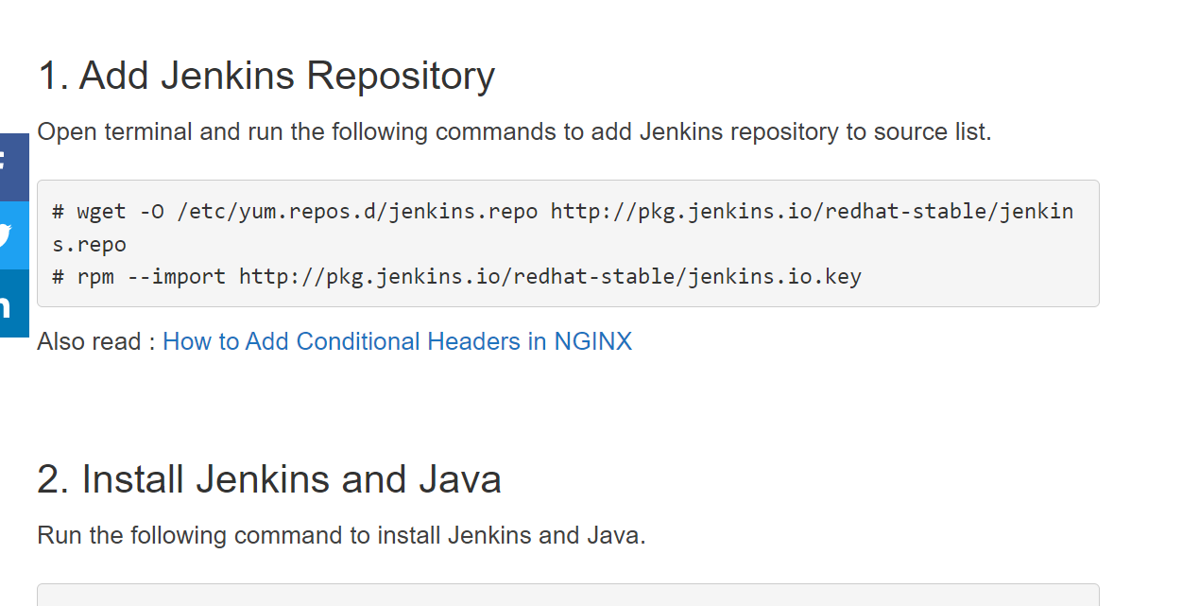

Quick way:

Use Java latest version and install jenkins

Sudo su –

yum install wget -y

**yum install java-11\***

**set java path in .bashprofie**

**find /usr/lib/jvm/java-1.8* | head -n 3**

**or $echo JAVA_HOME**

**wget -O /etc/yum.repos.d/jenkins.repo https://pkg.jenkins.io/redhat-stable/jenkins.repo**

**rpm --import https://pkg.jenkins.io/redhat-stable/jenkins.io.key**

yum install fontconfig java-11-openjdk -y

yum install jenkins -y

**systemctl enable jenkins**

**systemctl start jenkins**

systemctl status Jenkins

[DevOps - Mithun Technologies +91-9980923226: Jenkins Installation in RedHat Linux Server - Mithun Technologies - 9980923226 (mithuntechnologies-devops.blogspot.com)](https://mithuntechnologies-devops.blogspot.com/2022/09/jenkins-installation-in-redhat-linux.html?zx=15b4ed21164456e2)

[Maven – Installing Apache Maven](https://maven.apache.org/install.html)

Install maven also add path in .bash_profile as mentioned above

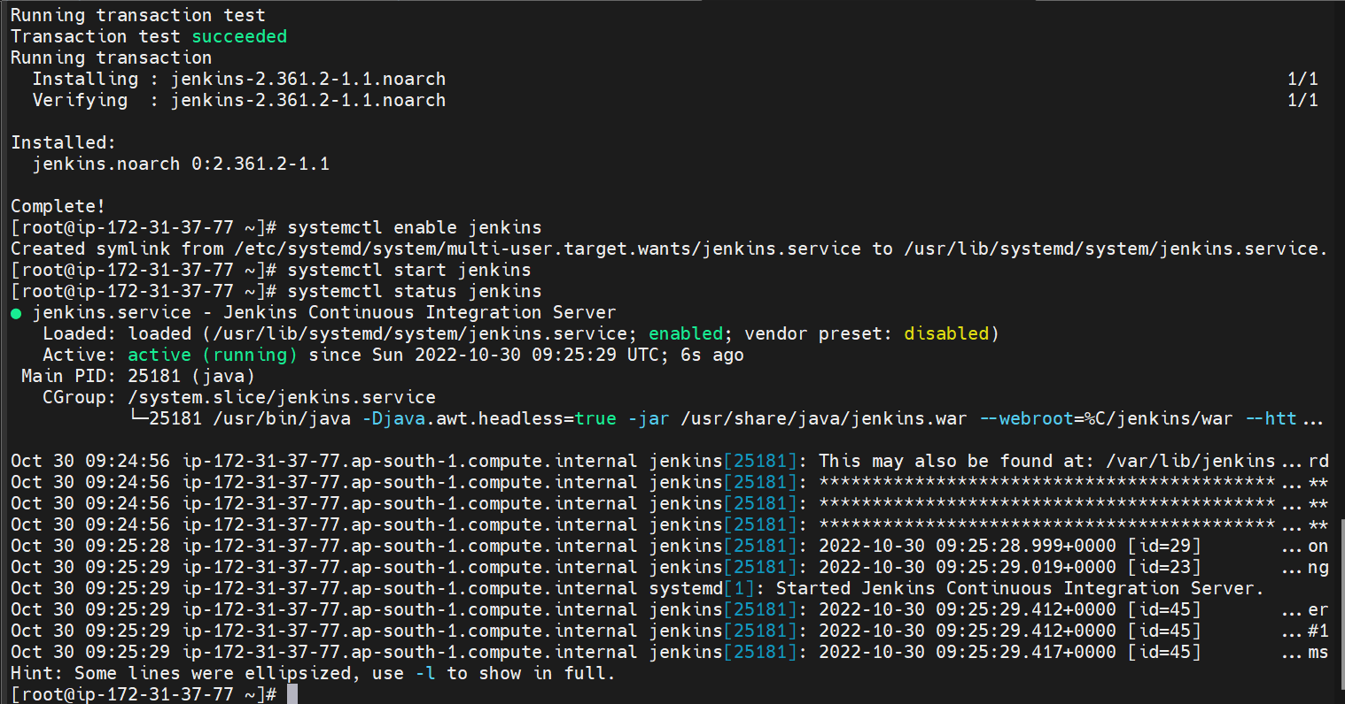

**Getting Started with Jenkins:**

Jenkins should know where maven , git , java is installed.

Manage Jenkins🡪Global tool configuration🡪Add JDK path, maven path, git path

(to know the path in MobXterm , type $echo JAVA_HOME/MAVEN_HOME/which git)

Create a New deployment

( It tests the code, compiles and creates WAR file)

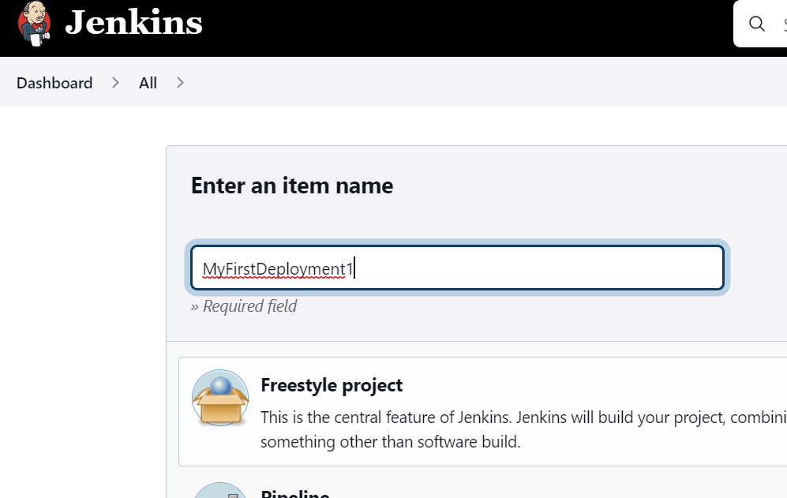

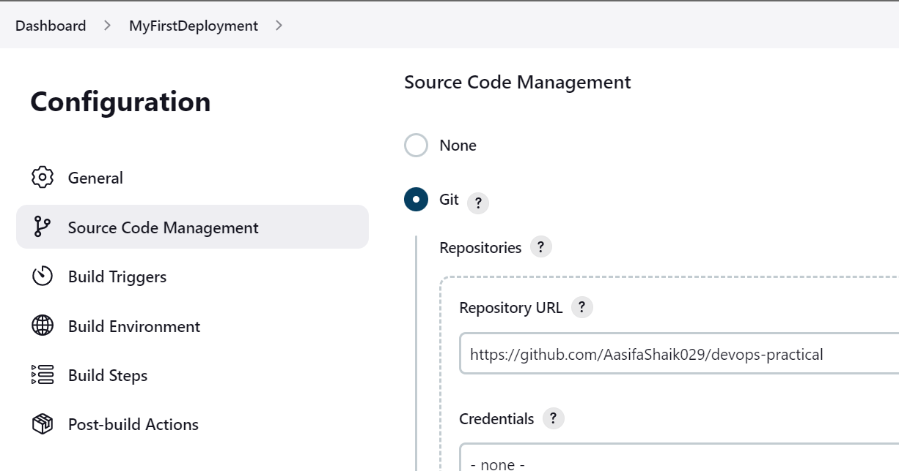

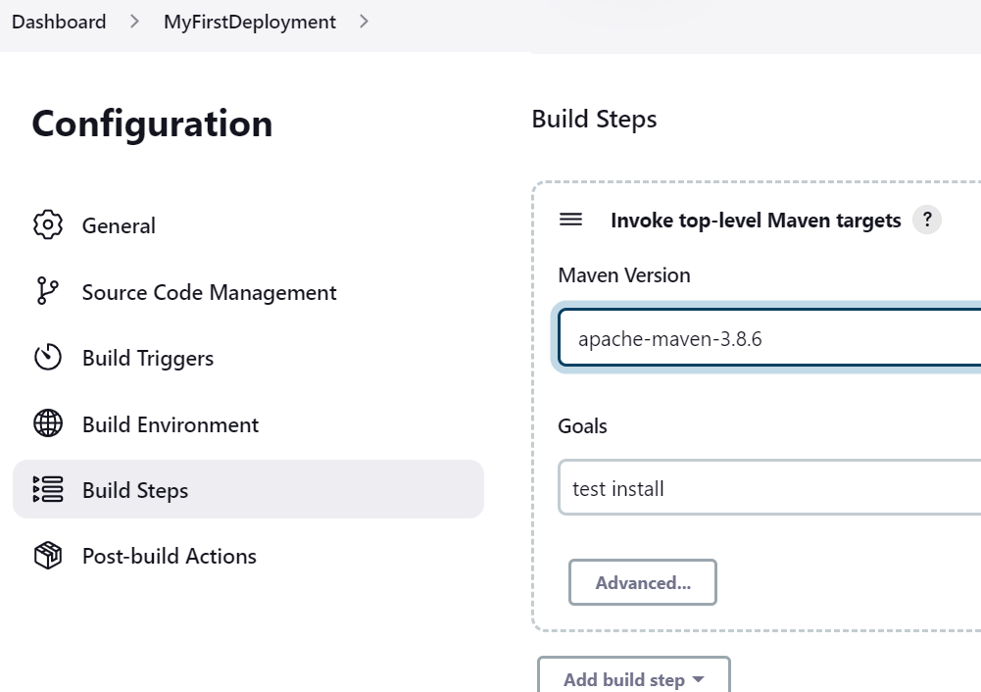

Add the repo, maven and correct java path and save

click on build now to build the job

check the console output

